**SL Unit 4** **– Problem Solving**  
Quiz 3

|  |  |  |  |
| --- | --- | --- | --- |
| **Question 1** | | | |
| Objectives: | 4.2.5 | Exam Reference: | May-16 10 |

Trace the following fragment, for N=139 and L=3, by copying and completing the trace table given  
below.

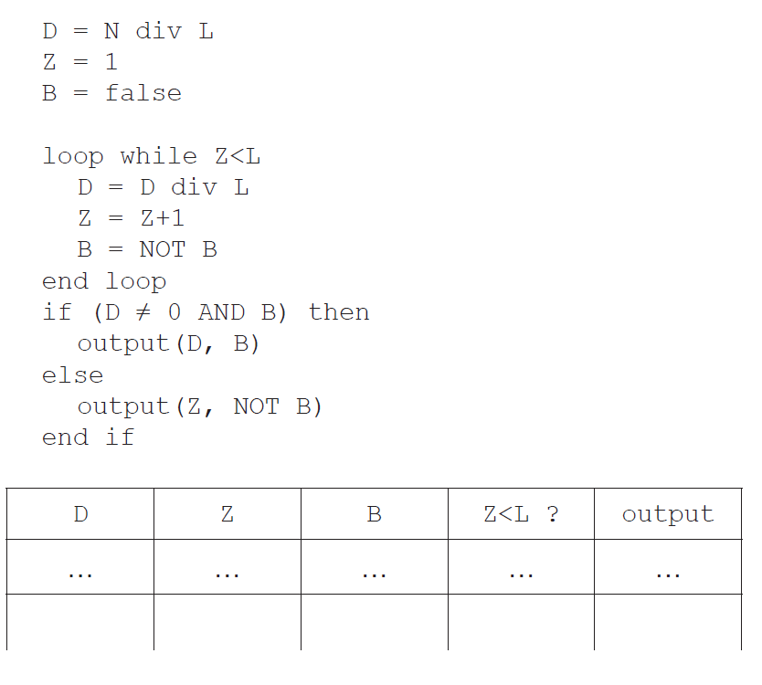

[4]

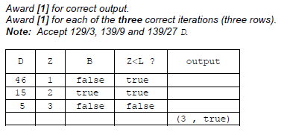

|  |  |  |  |
| --- | --- | --- | --- |
| **Question 2** | | | |
| Objectives: | 4.2.5, 4.2.6, 4.2.7, 4.3.13 | Exam Reference: | May-17 12 |

1. 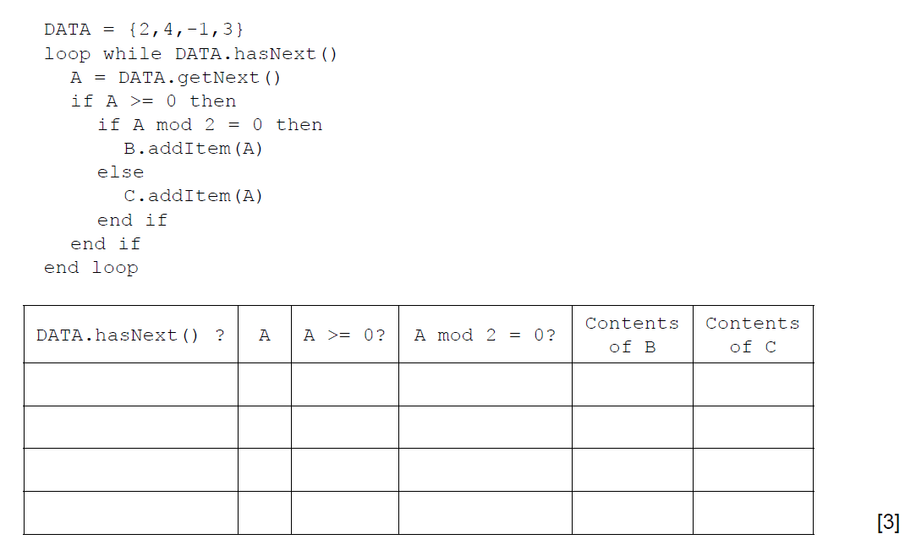 (a) By copying the table below, trace the following algorithm using the data in   
    the collection DATA. Note: B and C are also collections and are initially empty.

Award [***1]*** *mark if evident from the trace table that the loop executes exactly 4 times*

***[1]*** *mark for correct contents of B (2 and 4)*

***[1]*** *mark for the correct contents of C*

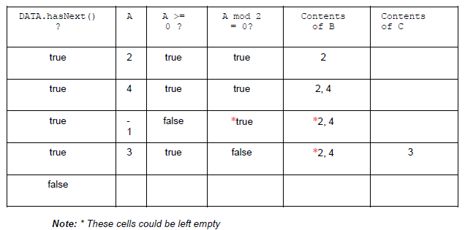

1. Outline the steps involved in performing a binary search on an array of ascending numbers.   
   **Note**: you can assume that the search value is present in the array and that initially LOW is the index of the first value in the array and HI is the index of   
   the last value. [4]

*Award* ***[4]*** *marks as follows:*

A position/index of the middle value calculated from HI and LOW;

If search value equals to value in the array at this position, then end;

Otherwise, change HI or LOW according to whether search value is above or below;

Repeat the process until search value is found;

*Example answer 1:*

1. Calculate MID (the midpoint of LOW and HI)

2. If ARRAY[MID] is the search value, end, else

3. If search value < than ARRAY[MID], HI = MID-1, else LOW = MID+1

4. Repeat steps 1, 2 and 3 until found

*Example answer 2*:

Find/calculate the midpoint/median value between HI and LOW;

If the array value at midpoint equals the search value; then the search value

is found;

If search value is greater than the array value at midpoint, set the midpoint as a new LOW and repeat the process - if search value is less than the array value at midpoint, set midpoint as a new HI;

Repeat until search value is found;

1. A collection called NUMBERS is to be searched to see if it contains a specified value.   
   Construct an algorithm in pseudocode to perform the following:

* input the number, S, to be searched for
* read in the values from the NUMBERS collection into the array D.   
  **Note**: you can assume that the array is large enough and that the collection is **not** empty
* perform a linear search for S on the array D
* output the message “found” or “not found” as appropriate. [5]

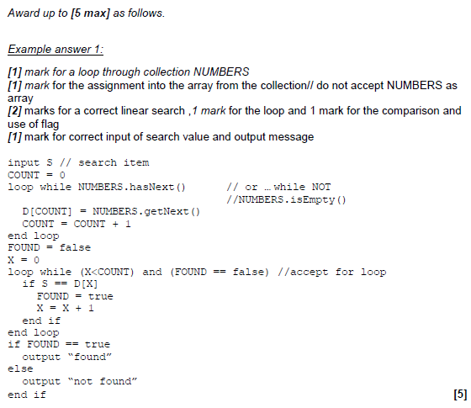

A binary search can be performed on the array D, if the values in D are in ascending order.  
As the values are being read from NUMBERS into D they are checked to see if they are in order.

Without writing pseudocode, suggest how this check could be performed. [3]

*Award up to* ***[3 max]****.*

***[1]*** *mark for setting and changing a flag*

***[1]*** *mark for starting from the 2nd entry and checking all values as being entered*

***[1]*** *mark for comparing the current value with the previous one*

***Note****: Do not accept pseudocode/code.*

|  |  |  |  |
| --- | --- | --- | --- |
| **Question 3** | | | |
| Objectives: | 4.3.4 | Exam Reference: | Nov-14 4 |

Outline the need for higher level languages. [2]

|  |  |  |  |
| --- | --- | --- | --- |
| **Question 4** | | | |
| Objectives: | 4.1.3 | Exam Reference: | May-15 3 |

Outline how a sub-procedure can be considered an example of abstraction. [2]

|  |  |  |  |
| --- | --- | --- | --- |
| **Question 5** | | | |
| Objectives: | 4.3.3 | Exam Reference: | Nov-17 1 |

Identify **two** essential features of a computer language. [2]